**Gordon College Uniform**

**Reservation System**

**(SCREENSHOTS)**

**Submitted by:**

**Group: Code Us**

**Fatrizha Alejah Boongaling**

**Beverly Karen Bernardino**

**Arshley L. Tan**

**Submitted to:**

**Ms. Mayer Z. Sanchez**

**Instructor**

**Login page (student)**

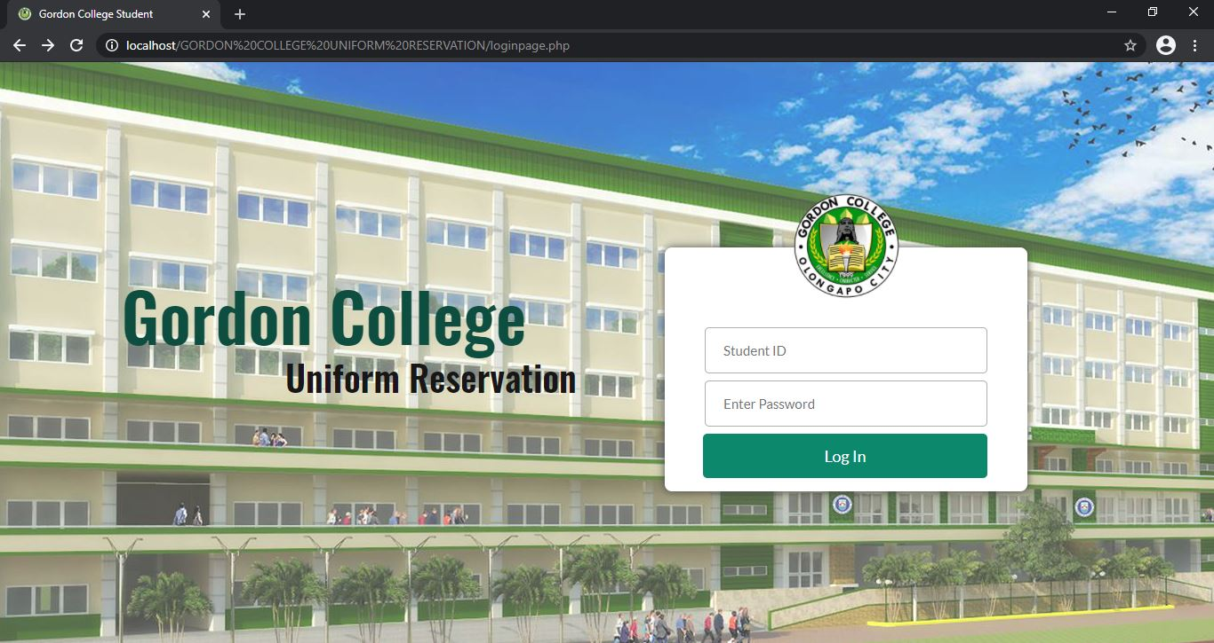

Login button

password

Student ID

**Homepage (student)**

Log Out button

Contact Us button

Account button

About button

Uniforms button

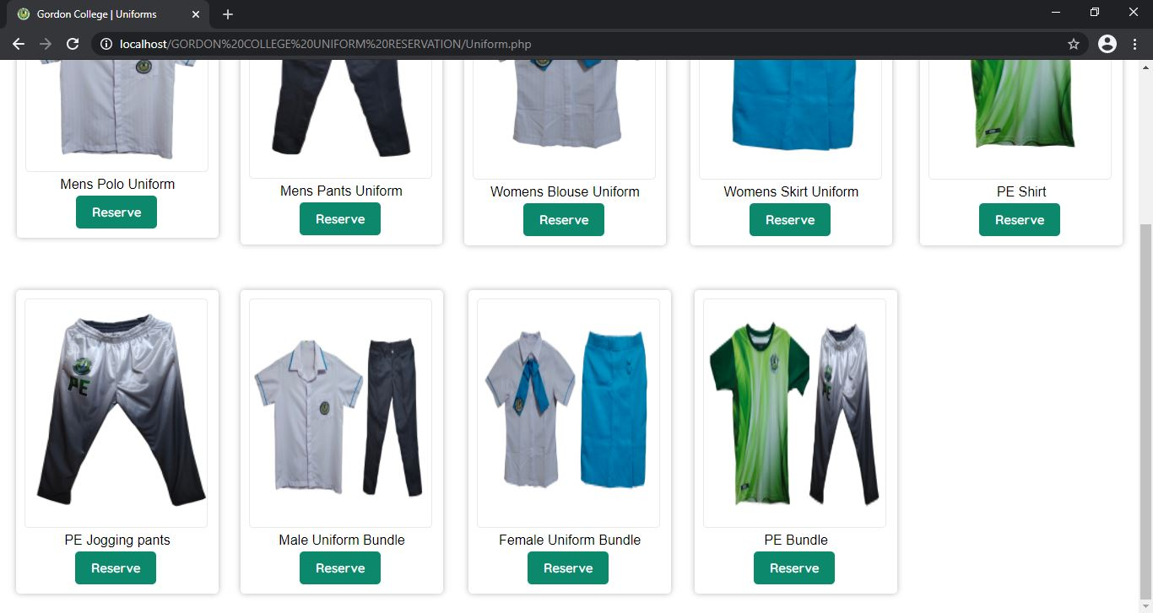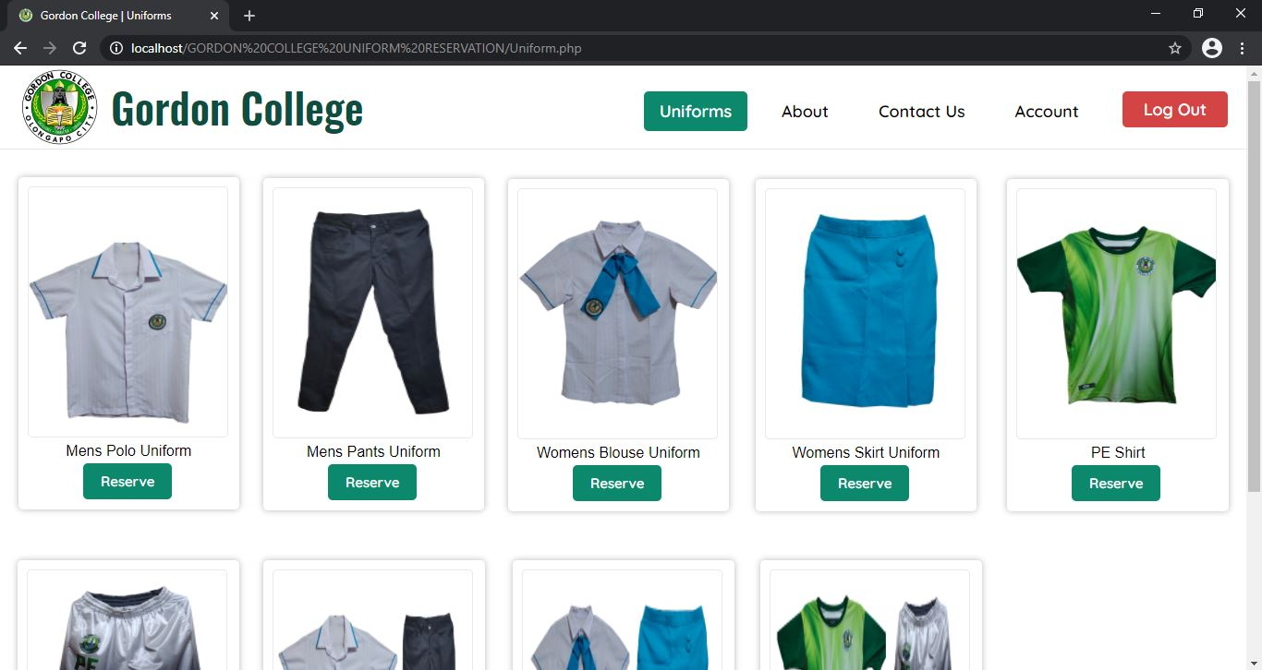

Navigation bar

Reserve Button

Reserve button modal pop-up (student)

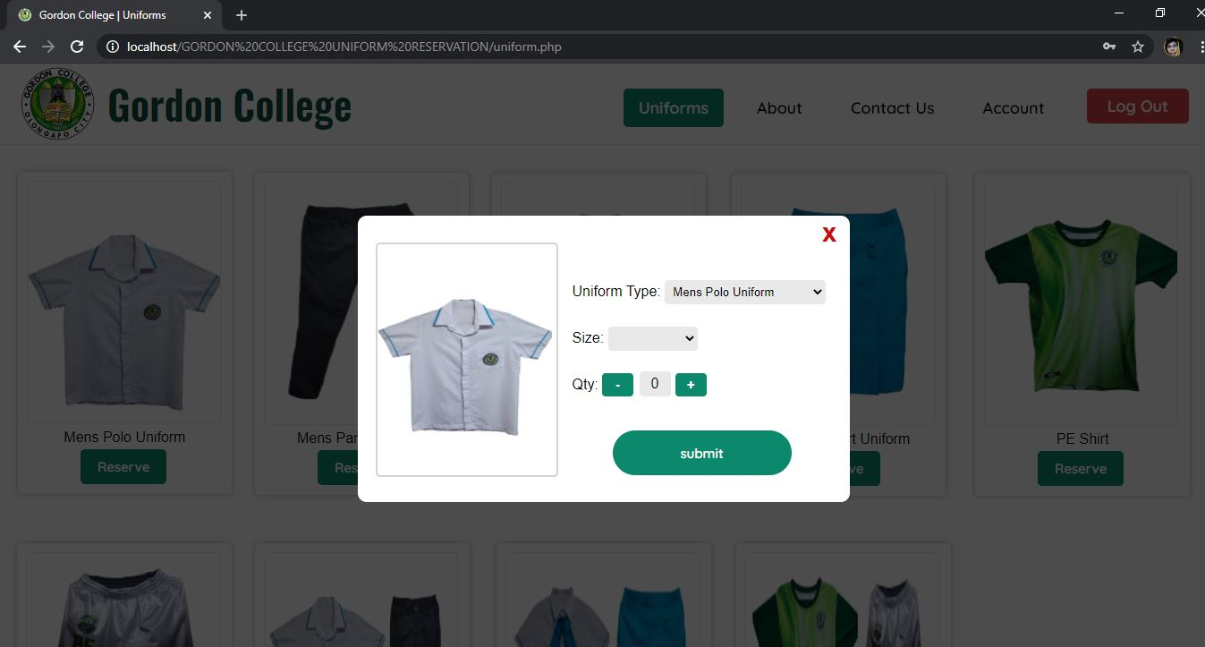

Dropdown menu uniform selection

Submit reservation button

Dropdown menu size selection

Increment and decrement quantity button

Uniform type is a dropdown menu type when you click it all of uniforms name will show. In this case you can order any type of uniform even if you click Mens Polo Uniform because of the dropdown menu that show the list of uniforms. The reason we created dropdown menu list is to get the name of uniform to pass it to the reservation database to know what type of uniform that user reserve. This is currently a bug for us. But to get the uniform name this is the only option so we put this drop -down menu selection of uniforms every click of reserve button this whole modal will pop up. There is a solution of this but we need to learn a new client-side script which is AJAX. When we know AJAX we will fix this. But for now, dropdown menu list is the only option.

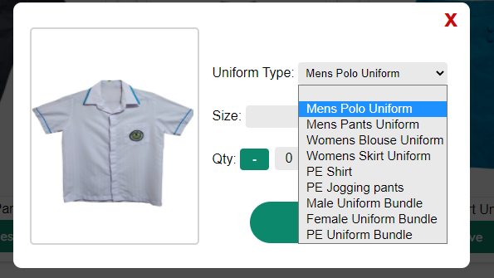

Screenshot of drop drown uniform list

About page (student)

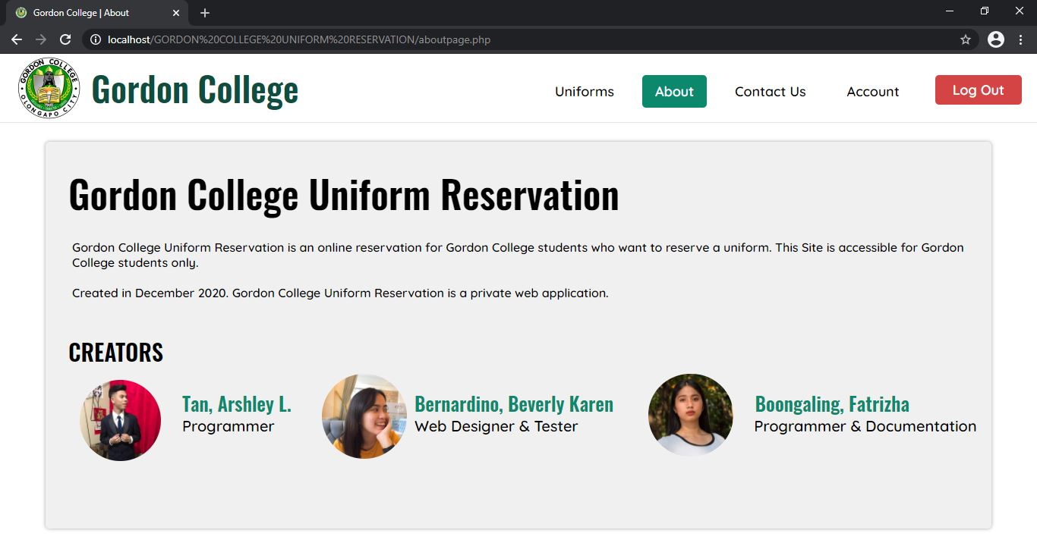

Contact us page (student)

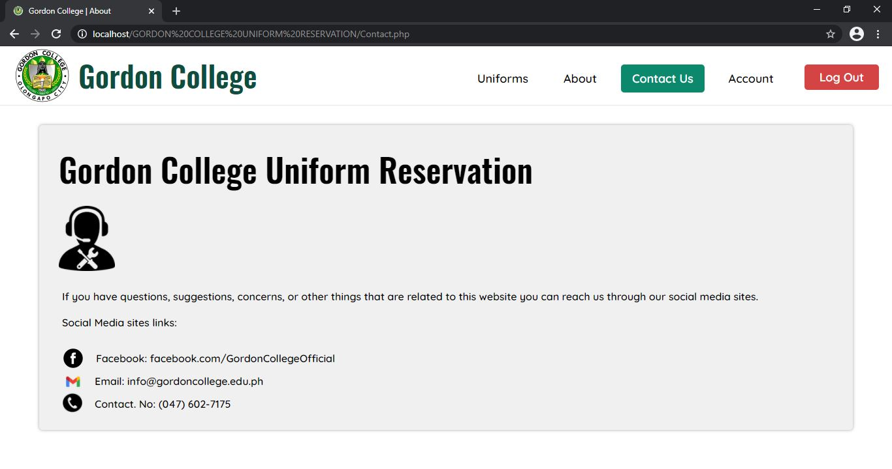

Clickable links

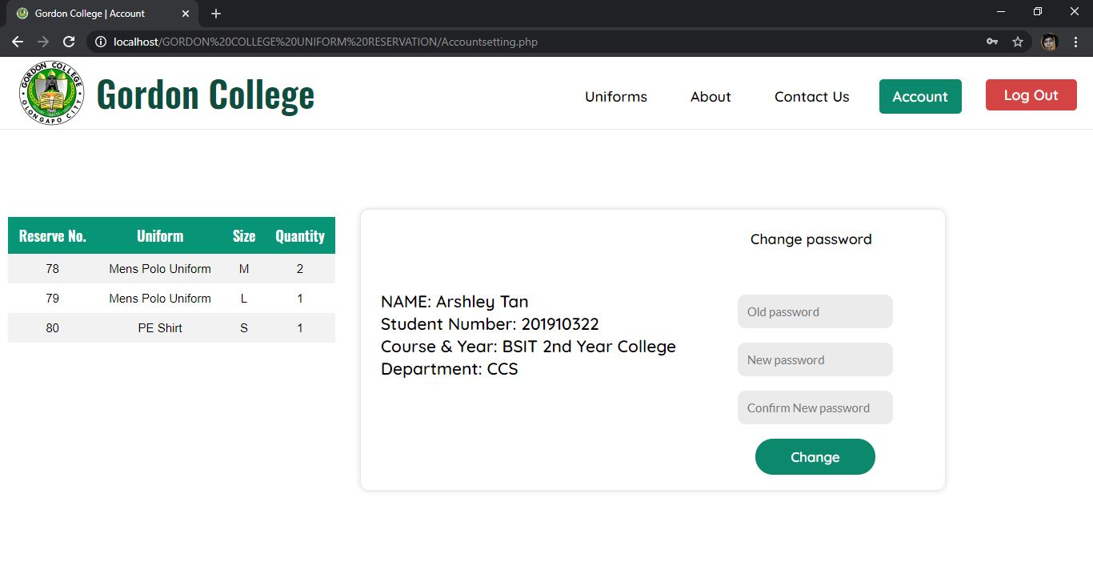Account page (student)

Old password field

new password field

Retype new password field

Change password button

Your reserved uniforms

Student information

(automatic show when login)

Login page (admin)

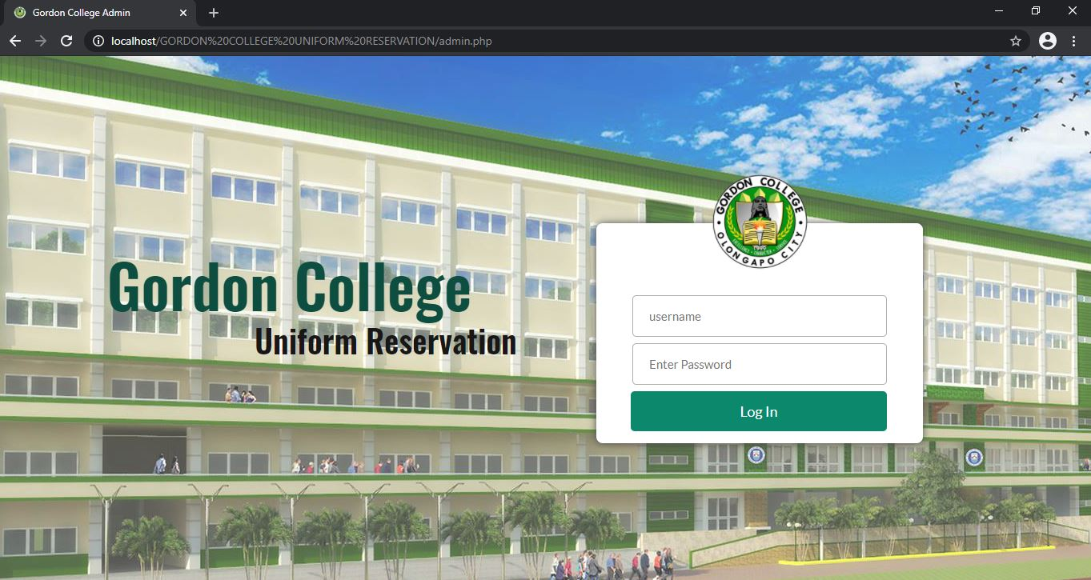

Login button

password

username

Reserve list page (admin)

Navigation bar

Reserve list button

Student account button

Account button

Log Out button

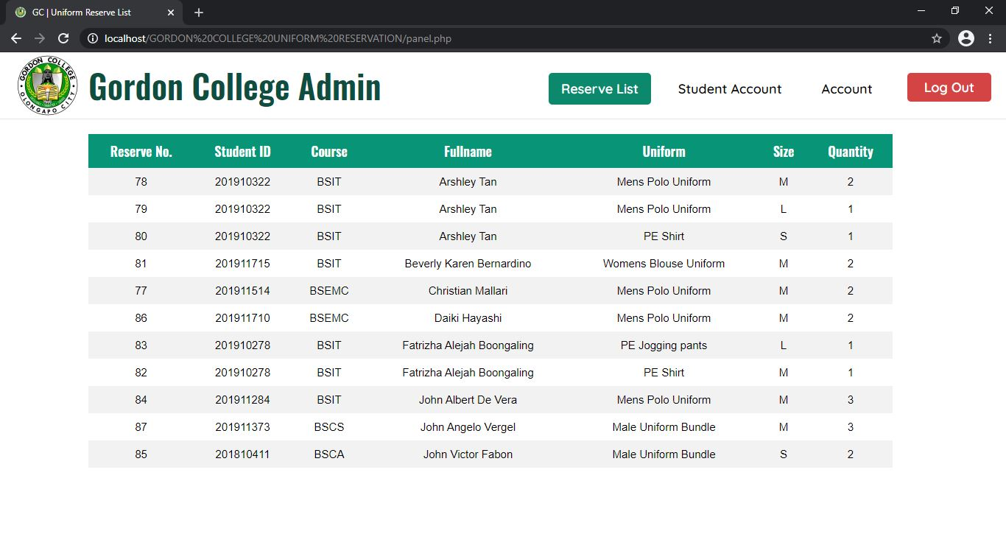

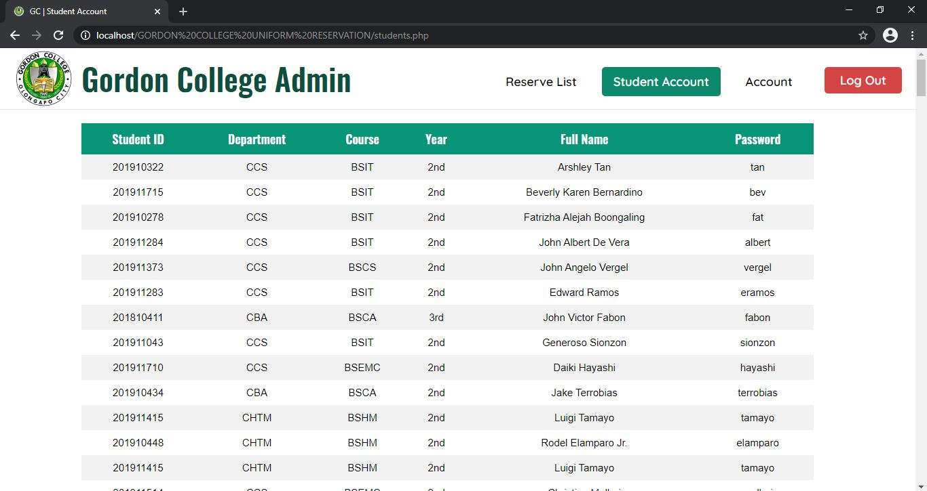Student List page (admin)

Account page (admin)

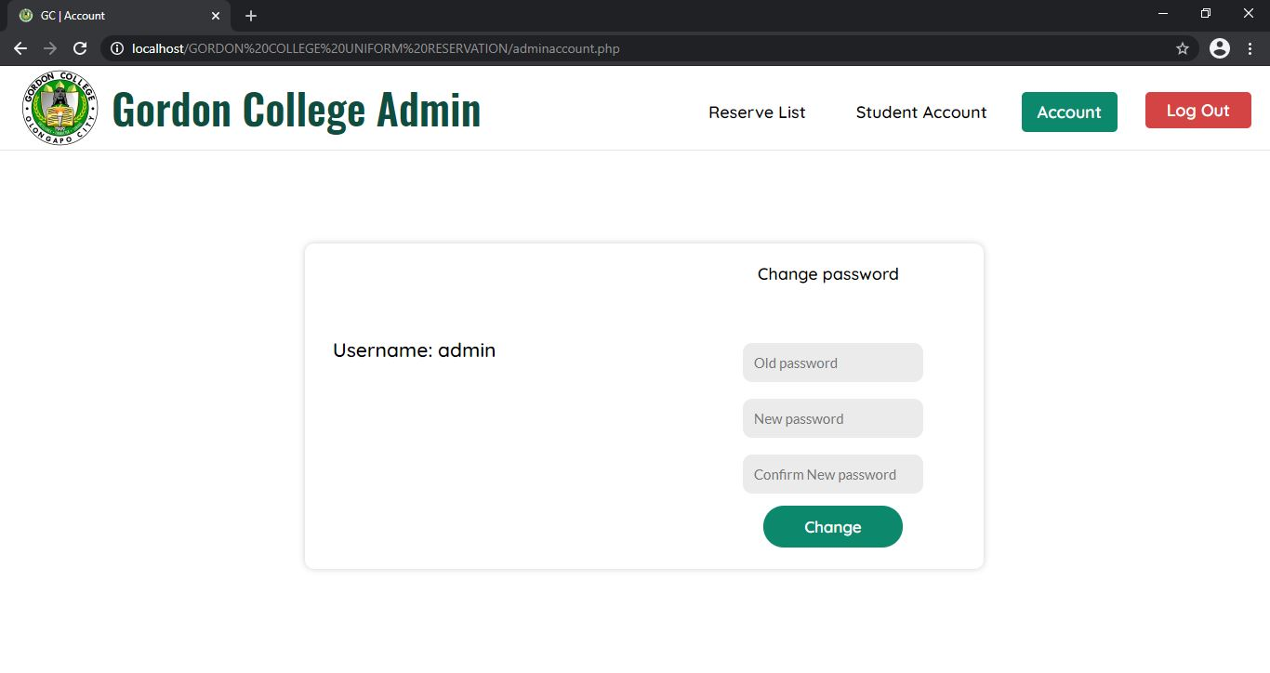

Username of account

Retype new password field

Change password button

New password field

Old password field